Welcome Back!!
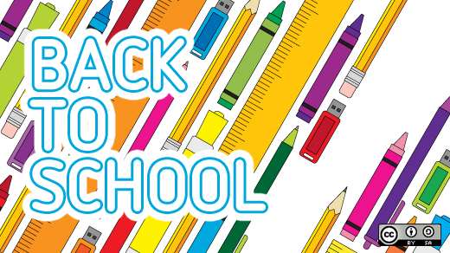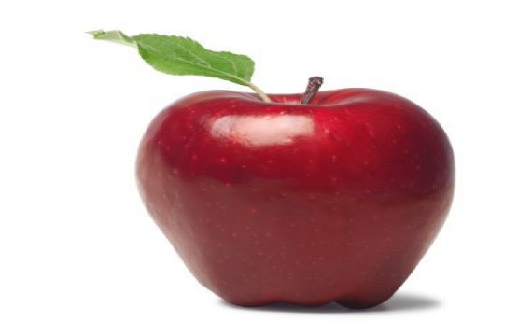

Fifth Grade School Supply List 2022-2023
Bristow Run Elementary School
Welcome to Fifth Grade!

2 – Composition notebooks (Language Arts)
2 – 1 subject spiral notebook (Math)
4 – Single pocket folders
24 – Sharpened pencils
1 – Pencil pouch
3 – Glue sticks
4 – Dry erase markers
1 – pencil sharpener
Scissors
Colored Pencils
Markers
Highlighters
4 Function Calculator
