Welcome Back!!
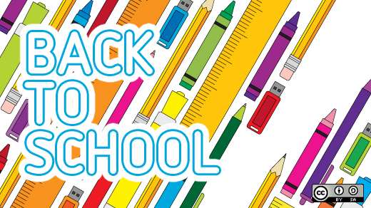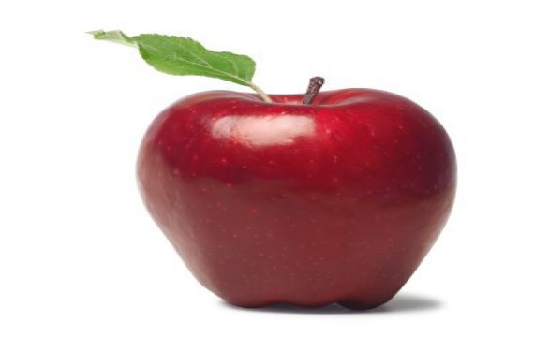

Third Grade School Supply List 2022-2023
Bristow Run Elementary School
Welcome to Third Grade!

Wired headphones for the computer (these will be JUST for your child)
Scissors (pointed)
5 – Spiral or Composition notebooks: wide ruled (solid color, one of each: green, red, yellow, black, and blue)
4 – Pocket folders (solid colors, plain- one of each color: green, yellow, red and blue) If you have some that are in good condition from last year, they can use these for this year.
4- Yellow highlighters
2 – Boxes of crayons OR colored pencils
24 – Sharpened pencils
1 – Pencil box or Pencil pouch (can be the same from last year IF in good condition)
8 – Glue sticks
12 – Black dry erase markers
1 – Pack of post-it notes 3x3
Erasers
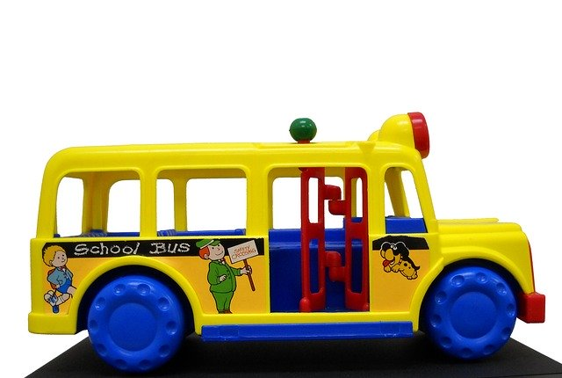
1 – Box of Ziploc bags
(Girls – sandwich size) (Boys – quart or gallon size)

Optional Items:
Markers – 8 count
Clorox wipes
Index cards

