Welcome Back!!
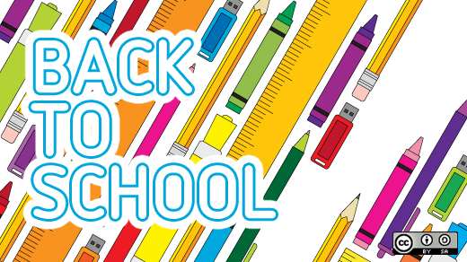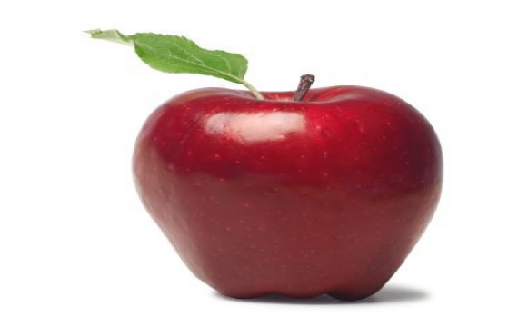

Second Grade School Supply List 2022-2023
Bristow Run Elementary School
703-753-7741
Welcome to Second Grade!

2 plastic pocket folders (red & green)
4 wide ruled composition notebooks
1 pair child scissors
2 boxes of 12 pencils
2 boxes of crayons (24 count)
10 glue sticks
Plastic pencil box aprox: 8”x4”x2”
1 pair of headphones or earbuds (for your child’s use only)

Optional supplies:
Markers
Colored pencils
2x2 sticky notes
