Welcome Back!!
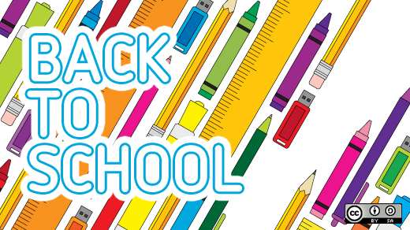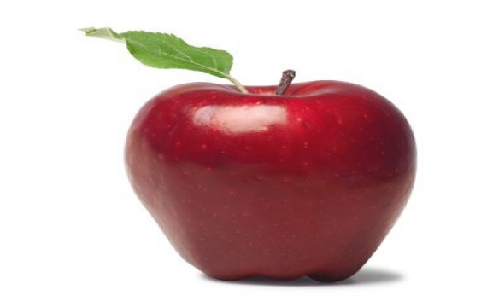

First Grade School Supply List 2022-2023
Bristow Run Elementary School
Welcome to First Grade!

2 Laminated/plastic 2-pocket folders
1 Laminated 3 prong folder
2 Packs – sharpened pencils
3 Primary composition notebooks (These have wider lines and a space at the top for an illustration.
12 Large Glue sticks
1 Plastic pencil box (large enough to hold pencils, box of crayons, glue and scissors – preferably 8”x5”)
1 Pack of thin dry erase markers
1 Pair of scissors
1 1-inch binder (3 ring)
2 Boxes of crayons (24 pack)
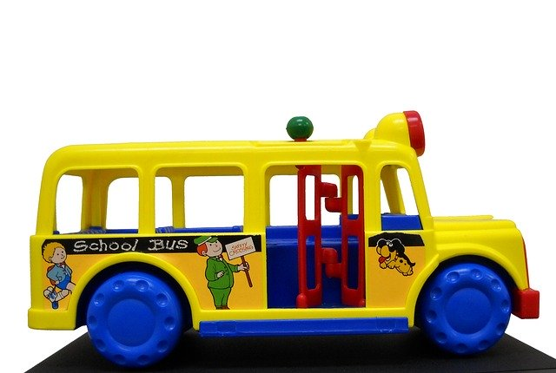
2 Packs of washable markers

Wish List Items (optional but greatly appreciated):
1 Pack colored pencils (for class use/not individual use)
1 box of gallon size zip top bags
1 box of sandwich zip top bags
Treasure Box prizes

